# FIRST WEEK CHALLENGE

# SHAOYUAN WANG

After intense Arduino study last week, this week we focus more on our ideas. I developed my idea of digital coaster at first but it is not understandable idea because of the difference between Chinese and British culture. So I was looking for better problem afterwards. Occasionally, I had new idea after meeting with friends. They inspired me. The idea is about social exercise. My friends don’t have much time to go to gym because of heavy desk-work. So usually they are not able to go to bed until late night. Therefore, their back and shoulders are quite stiff. At the same time, they are getting more fat since they spend most of time on chair. And another reason of lack of exercise is laziness. It is difficult to have motivation to do some sports if they are alone.

However, we stretch a bit together and try to do yoga or indoor sports together when we gathered at someone’s flat. This scenario enlightened me to make product for friends to enjoy doing exercise. After that, I found that one of factors of doing sports with more passion is working out in group. Group exercise can happen among family members or friends with nice interaction for fitness.

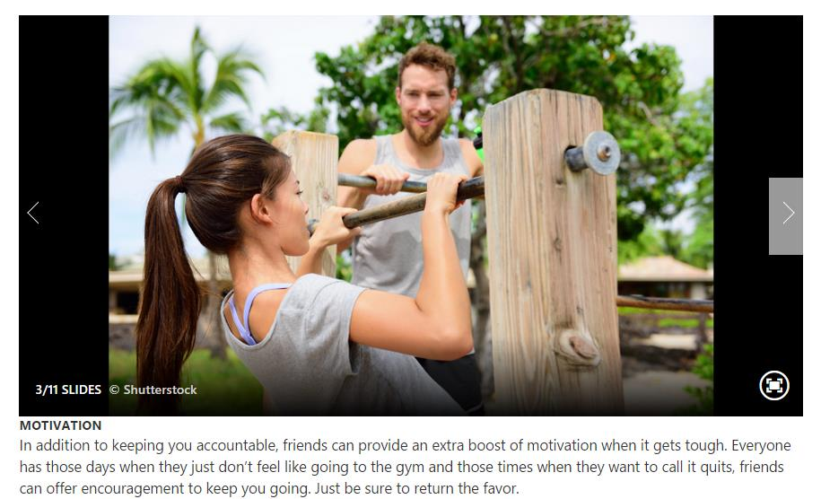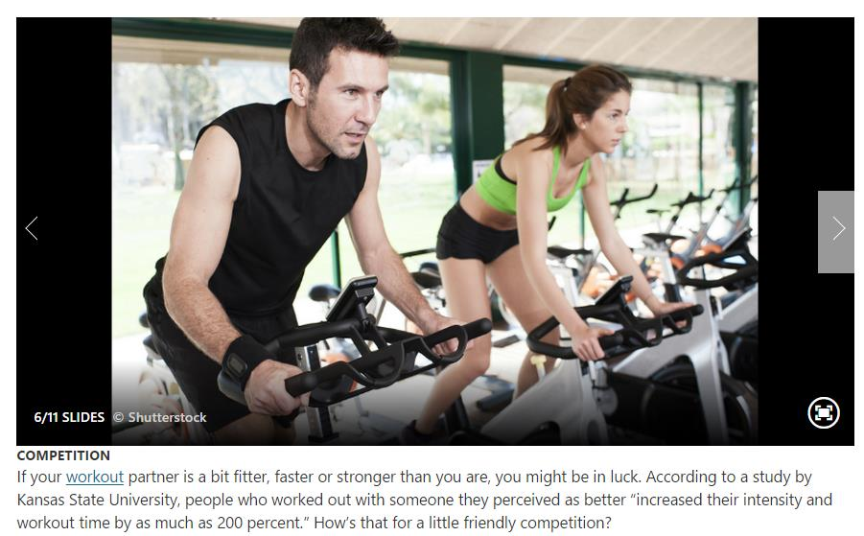

Working out with friends is better than exercising alone, researchers say. A study of 1,000 women found that 64 per cent of those who run, go to the gym or attend group exercise classes with chums will push themselves harder than if they went alone. Those who exercise together train for longer, burn more calories and go to the gym more often.

The target suppose to be the people don’t do much exercise or work a lot at desk. For them, I searched some light indoor exercise online which can relax their muscle. Twisting waist on spin chair is suitable for them because it is easy and not strenuous.

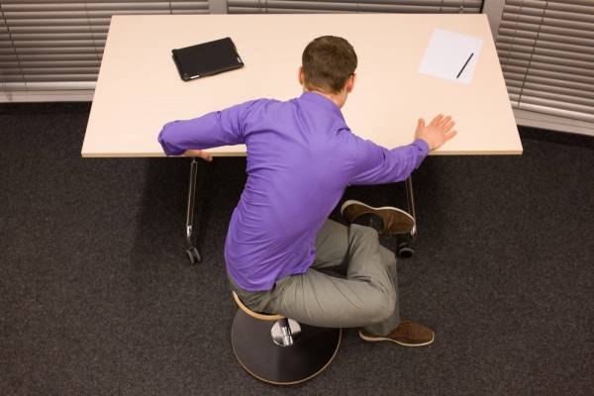

My original idea was that the lamp will be turned off on time (10:30p.m) to tell you to take a break potentially, then the LED light will be on to invite you to join to do exercise together when the members start twisting their waists. But this is a little complicated as a product design. I should focus on one aspect instead of linking many different things. Sometimes it is easier to make concept not strong enough or too complex when I have many thoughts of possible function. After the advice from Fraser and Martin, I amended my idea, which focus on the method of encouraging members to do exercise together(at the same time).

I started looking at the portable equipment - dumbbell.

The main merits of dumbbell:

1. Portable, doesn’t need much space
2. Balance body and muscle
3. Safer
4. Good for shoulders, back
5. The place doesn’t matter

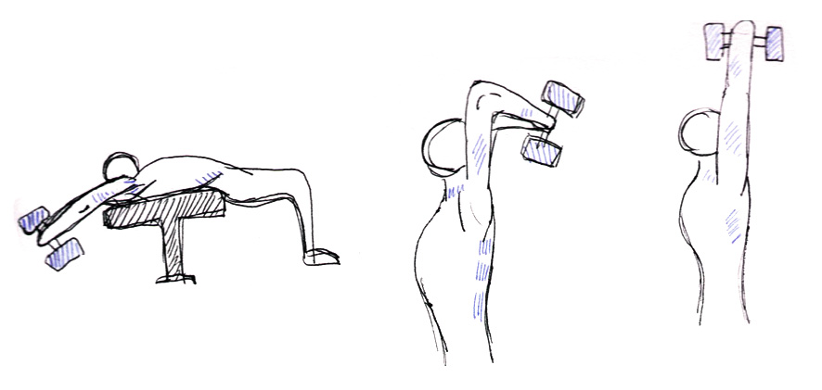

The current idea is Digital Dumbbell.

The dumbbells are connected, so the lights of dumbbells will be aromatically on when people start doing exercise. It invites your friends or the people you are linked to do exercise together. More people join more lights blink.

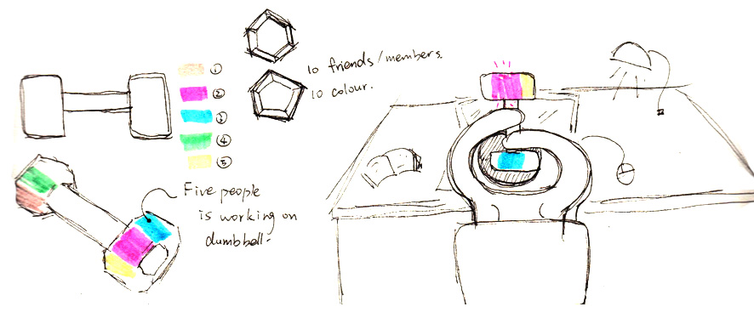

For next week, I would like to figure out the technology part to support my concept.